July 2022

Initial Risk Assessment

Audit of the UNESCO

Office in Havana

**Declaration of non-conflict of interest: The audit team has read and understood the Code of Ethics for Internal Auditors. The audit team agrees to adhere to the Code of Ethics and, should the audit team have any questions or encounter any circumstances potentially impairing the adherence to the Code such as conflict of interest, the audit team will immediately bring them to the attention of their supervisor or to the IOS Director.**

During the preparation of IRA, please comply with the IIA Standard 1220.A1. – Internal auditors must exercise due professional care by considering the:

* Extent of work needed to achieve the engagement’s objectives;
* Relative complexity, materiality, or significance of matters to which assurance procedures are applied;
* Adequacy and effectiveness of governance, risk management, and control processes;
* Probability of significant errors, fraud, or noncompliance; and
* Cost of assurance in relation to potential benefits.

Table of contents

BACKGROUND 3

UN AGENCIES 4

OFFICE STRATEGY, STRUCTURE AND PORTFOLIO 5

RISK MANAGEMENT 12

CONTROL ACTIVITIES 13

DATA ANALYSIS 16

INFORMATION AND COMMUNICATION 18

PARTNERSHIPS 18

PRELIMINARY FINDINGS 19

AUDIT RATIONALE, SCOPE AND OBJECTIVE 19

|  |
| --- |
| BACKGROUND |

**Office Role**

The UNESCO Regional Centre for the Western Hemisphere was established in 1950 and is simultaneously a Regional Office for Culture in Latin America and the Caribbean, a Cluster Office to Cuba, Dominican Republic, and Haiti, as well as UNESCO´s Representation to the Governments of Cuba and Dominican Republic. The objective of the office is to promote programs and initiatives in the field of culture for the 37 Member States and Associate Member States of the region, with the aim of contributing to the preservation of tangible and intangible cultural heritage, the promotion of creativity, the development of cultural industries, the promotion of pluralism and intercultural dialogue, the safeguarding of diversity and the encouragement of cultural integration processes.[1]

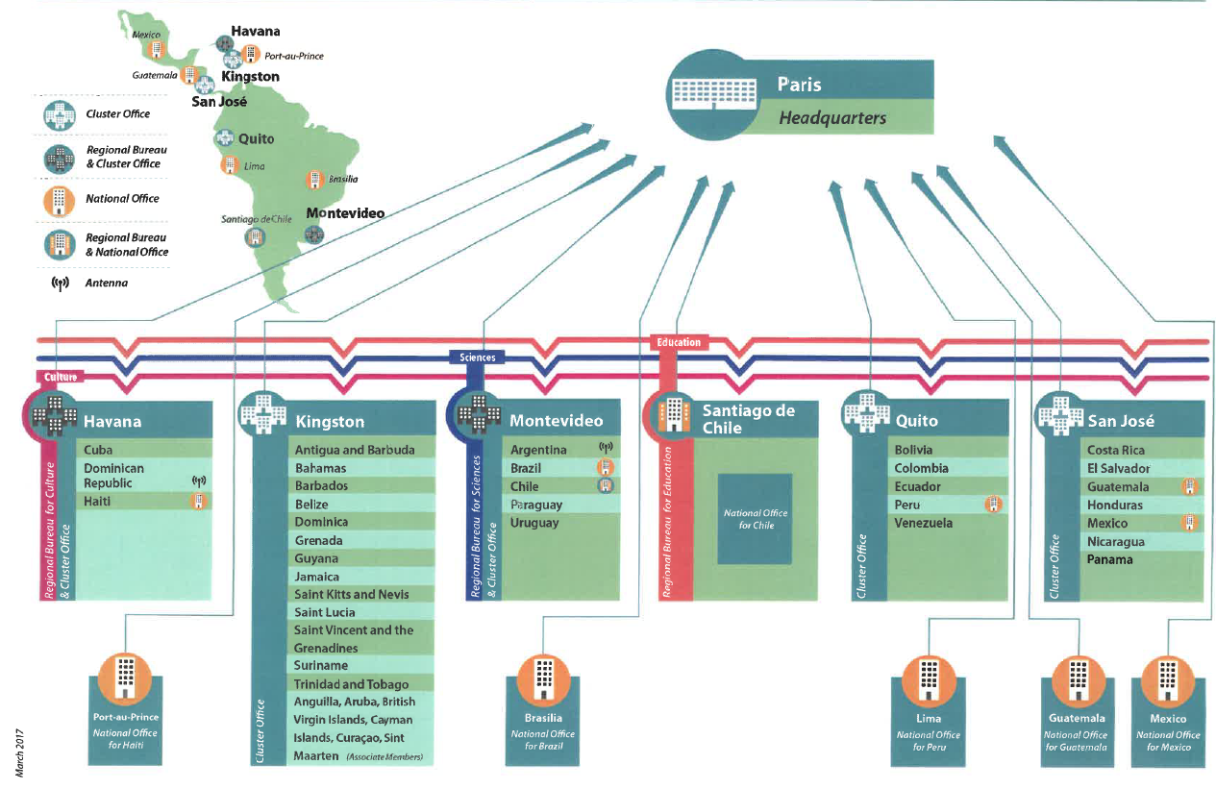

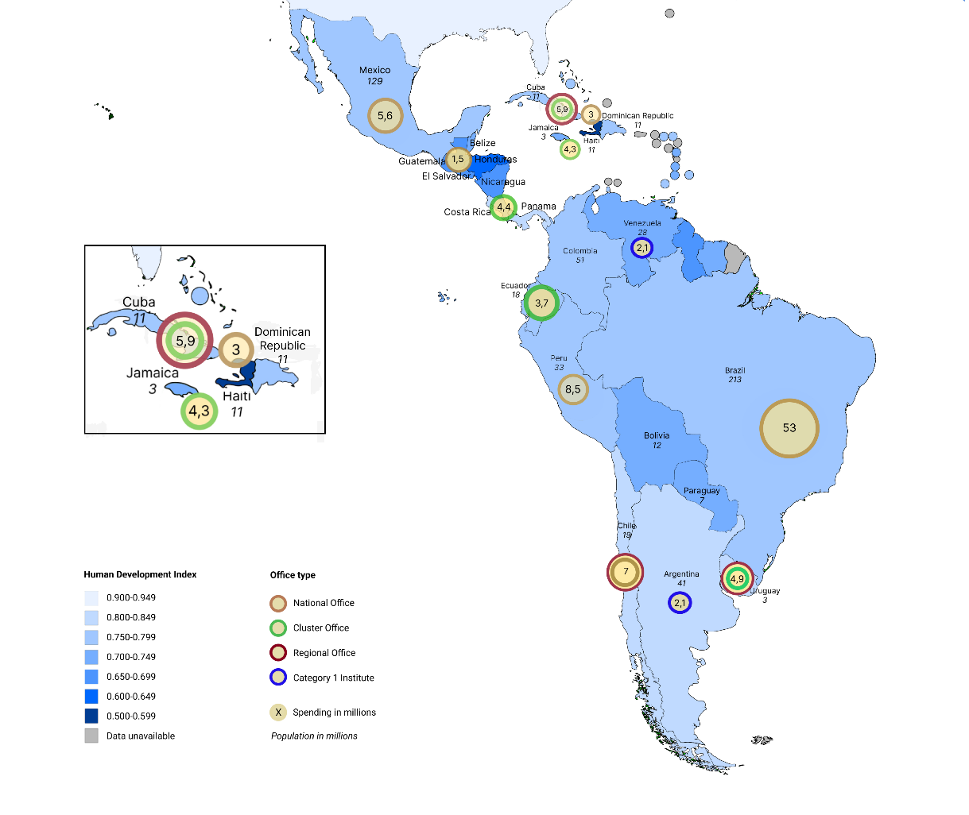

**Figure 1. UNESCO Offices´ spending between 2019 and 2022 in the LAC region**

**Context of the region**

The corruption perception indices (CPI) are especially low on a scale of 0 (very corrupt) to 100 (very clean) for Haiti and Dominican Republic.

|  |  |  |  |  |
| --- | --- | --- | --- | --- |
| **Countries** | **Population**[2] | **CPI score** | **Rank /180** | **Evolution** |
| Cuba | 11.3M | 46 | 64 | The country lost 1 point since 2020 |
| Dominican Republic | 11.1 M | 30 | 128 | The country gained 2 points since 2020 |
| Haiti | 11.7M | 20 | 164 | The country gained 2 points since 2020 |

*Source:* [*https://www.transparency.org/en/cpi/2021*](https://www.transparency.org/en/cpi/2021)

|  |
| --- |
| UN AGENCIES |

**Office** UNESCO’s presence in Cuba represents the third in terms of number of agencies and international staff as shown below. UNESCO has presence in all the three countries.

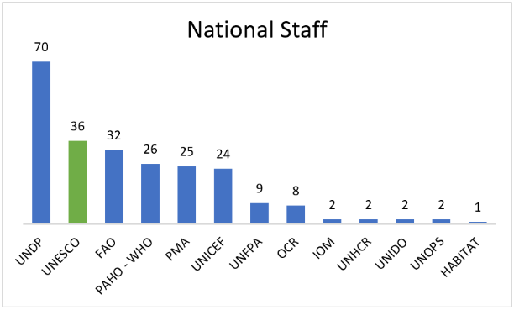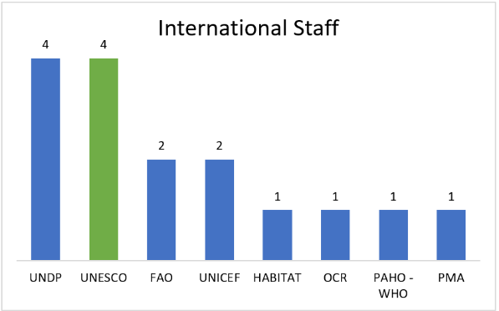**Cuba:** 13 agencies, 16 international staff and 239 local staff

Source: UNDSS Staff List 28 Apr 2022

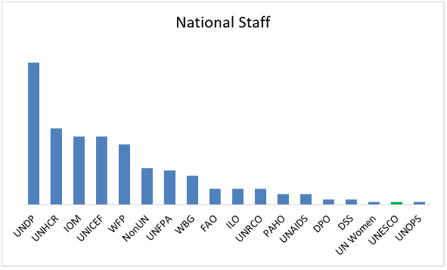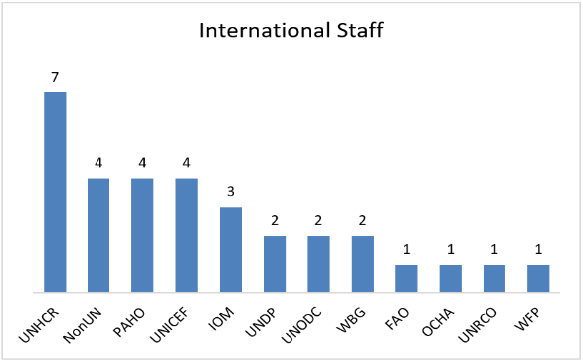**Dominican Republic**: 20 agencies, 32 international staff and 229 local staff

Source: UNDSS Staff List 31 Mar 2022

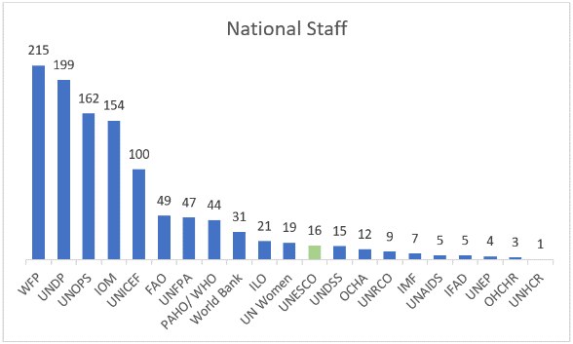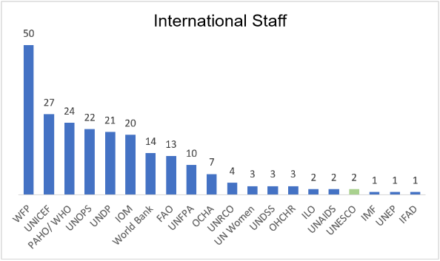**Haiti**: 21 agencies, 230 international staff and 1118 local staff

|  |
| --- |
| Source: UNDSS Staff List 14 Apr 2022OFFICE STRATEGY, STRUCTURE AND PORTFOLIO |

**UN and Office Strategy**

|  |  |  |  |  |
| --- | --- | --- | --- | --- |
| **Countries** | **UNDP Human Development Index (HDI) 2019[3]** | **UNDAF Period (or Cooperation Framework from 2019 on)** | **UNDAF/Cooperation Framework priorities for the achievement of the SDGs** | **UCS Expected Results** |
| **Cuba** | 0.783 (70th position) – High human development | 2020-2024 (Cooperation Framework) | * Effective government: territorial development, statistical system, and social participation. * Productive transformation: productive chains, agrifood systems, quality jobs, development financing and sustainable energy. * Natural resources and environment: natural resources, ecosystems and environmental quality, climate change and disaster risk management. * Human development and equity: social services, protection and care system, food access and consumption, and adequate habitat. | **UCS as Regional Office for Culture**   * Cultural heritage: enhance heritage site management capacities and support the updating of cultural heritage inventories, registers, and lists, and support the mapping of cultural resources. * Culture for Sustainable Development: strengthen its role and the linkages between stakeholders to promote it. * Support cultural and creative sector capacity building, entrepreneurship, and opportunities for employment. * Promote cooperation, knowledge sharing and cultural exchange in the region and with other regions. * Culture in Education: foster respect and appreciation for cultural diversity. * Assist Member States in the region with culture related matters. * Support the ratification and implementation of UNESCO Culture Conventions in the LAC Region. * Develop and disseminate awareness raising materials and information about UNESCO´s work in the region. |
| **Dominican Republic** | 0.756 (88th position) – High human development | 2018-2022 | * Poverty, food security and environmental sustainability: reduction of economic and social gaps, food and nutritional security, socio-environmental sustainability, and resilience to climate change. * Social services and gender equality: quality health, access to health services for children and women, learning opportunities for children and youth, and gender equality. * Institutional strengthening and human rights: strengthening of public institutions for sustainable development and human rights, and production of statistics. |  |
| **Haiti** | 0.510 (170nd position) – Low human development | 2017-2021 | * Poverty reduction and employment. * Basic social services. * Gender equality and protection. * Resilience and Governance. |  |

**Resource Mobilization**

The Office developed a resource mobilization plan for 2018-2019 and has since mobilized resources for the $15m EU-funded Transcultura project.

**Donors’ landscape**

The map below shows how Net Official Development Assistance (ODA)[4] received per capita (current US$) varies by country in Central America and the Caribbean. The shade of the country corresponds to the magnitude of the indicator. The darker the shade, the higher the value. The country with the highest value in the region is St. Vincent and the Grenadines, with a value of 763.88. The country with the lowest value in the region is Cayman Islands, with a value of -59.59.

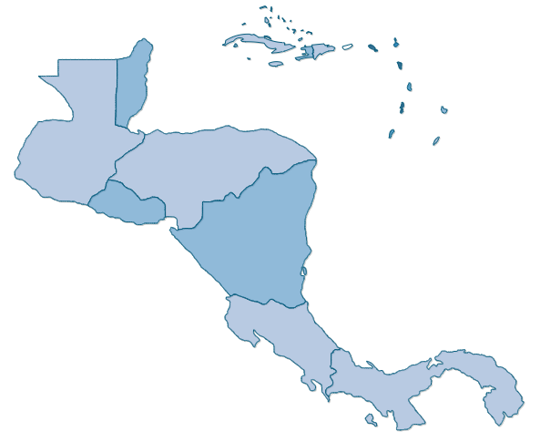  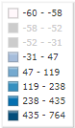

[*Net ODA received per capita (current US$) - Central America & the Caribbean (indexmundi.com)*](https://www.indexmundi.com/facts/indicators/DT.ODA.ODAT.PC.ZS/map/central-america)

**Donors’ requirements**

|  |  |  |  |  |  |  |
| --- | --- | --- | --- | --- | --- | --- |
| Budget code | Project title (full) | Donor | Sector | Valid from | Valid to | Allocation |
| 513CUB4000 | Jardines de la Reina National Park: Technical support to strengthen management & possible future World Heritage nomination file preparation | Flanders | CLT | 01-01-19 | 30-04-22 | 49,720 |
| 514CUB4002 | Old Square Project: Promoting culture and sustainable development within the framework of the celebration of the 500th Anniversary of the Historic Centre of Old Havana and its Fortification System | SPAIN | CLT | 01-02-21 | 31-01-23 | 250,000 |
| 549RLA4000 | Transcultura Integrating Cuba, the Caribbean and the European Union through Culture and Creativity | EU | CLT | 01-12-19 | 30-11-23 | 15,621,429 |

The Office manages three projects directly (i.e., under the HAV fund centre), all of them in Culture, including a big project funded by the EU.

**Evolution of the donors for the Office**

Historically funds have mostly come from multi-donor funds and Spain. Since 2020 the EU has been the largest fund, reaching over 2M funds in 2021.

**Trend in budget and expenditures**

Culture is the sector that spends the most, with increasingly growing expenditure since 2019.

*Source: ZPOLIST by purchasing group*

As shown below, most activities are funded with a regional (RLA) or global (GLO) scope as well as with specifications of beneficiary country such as Cuba (CUB) and Dominican Republic (DOM).

*Source: ZPOLIST by purchasing group*

**Regular Programme Budget**

The Regular Programme (RP) budget for 2022-2023 amounts to nearly US$2.4 m, with a considerably lower budget for programme activities than for Office’s running costs as shown in the table below. In 2022-2023 over 500K were allocated to FLD RP staff costs in ADM, a cost that did not exist in the previous biennium. In addition to this, the staff costs in all the sectors except for SC had a slight increase.

|  |  |  |  |  |  |  |
| --- | --- | --- | --- | --- | --- | --- |
| **Budget / Biennium** | **2018-2019** | **%** | **2020-2021** | **%** | **2022-2023** | **%** |
| Office Running Costs | 502,128 | 68% | 582,573 | 25% | 487,798 | 21% |
| Programme Activities | 238,182 | 32% | 284,973 | 12% | 204,936 | 9% |
| Staff Costs | No data | - | 1,489,730 | 63% | 1,669,628 | 71% |
| **Total** | 740,310 | 100% | 2,357,275 | 100% | 2,362,362 | 100% |

*Source: YFM1 2018-2023*

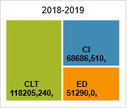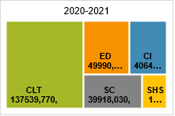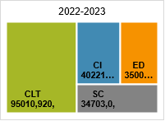The RP budget for programme activities is broken down by sector in the table below.

The figure below shows the breakdown of RP budget and the EXB spending as well as the fixed-term posts allocated to the Office by sector for the 40/C5 as of June 2022.

**Voluntary Contributions**

The Office manages a portfolio of 3 projects which have an end date in 2022 and 2023.

|  |  |  |  |  |  |  |  |
| --- | --- | --- | --- | --- | --- | --- | --- |
| Budget code | Project title (full) | Donor | Sector | Valid from | Valid to | Allocation | Execution Rate |
| 513CUB4000 | Jardines de la Reina National Park: Technical support to strengthen management & possible future World Heritage nomination file preparation | Flanders | CLT | 01-01-19 | 30-04-22 | 49,720 | 98% |
| 514CUB4002 | Old Square Project: Promoting culture and sustainable development within the framework of the celebration of the 500th Anniversary of the Historic Centre of Old Havana and its Fortification System | SPAIN | CLT | 01-02-21 | 31-01-23 | 250,000 | 4% |
| 549RLA4000 | Transcultura Integrating Cuba, the Caribbean and the European Union through Culture and Creativity | EU | CLT | 01-12-19 | 30-11-23 | 15,621,429 | 34% |

Source: YPS8 projects released from the ZPOLIST

Between 2018 and 2022, the Office received funds from 11 16 different budget codes including 2 RLA (of which one under the Office’s responsibility) and 6 GLO.

|  |  |  |  |  |  |
| --- | --- | --- | --- | --- | --- |
| **Fund** | **Project Title** | **Donor** | **Fund Centre/Implement Unit** | **Sector** | **Ordered amount (USD)** |
| 549RLA4000 | Transcultura Integrating Cuba, the Caribbean and the European Union through Culture and Creativity | EU | HAV | CLT | 3,755,657 |
| 514INT4000 | UNESCO - Spain FIT in favour of World Heritage Centre | Spain | WHC | CLT | 52,844 |
| 537RLA2000 | Capacity Building for DRR in the Built Environment in Latin America and the Caribbean | Japan | EES | SC | 38,398 |
| 513CUB4000 | Jardines de la Reina National Park: Technical support to strengthen management & possible future World Heritage nomination file preparation | Belgium | HAV | CLT | 37,959 |
| 354GLO5009 | Media development is strengthened (IPDC Non-earmarked Project Series 2021) | Multi-donor | IPD | CI | 32,613 |
| 257GLO1041 | UNAIDS UBRAF 2018-2019 core contribution for UNESCO's work on HIV prevention and comprehensive sexuality education | UN | IPS | ED | 19,287 |
| 354GLO5006 | Media development is strengthened, and Member States have improved monitoring and reporting systems and these results are reinforced by external grassroots projects supported by the IPDC in 2018 (Non-earmarked series) | Multi-donor | IPD | CI | 10,300 |
| 514CUB4002 | Old Square Project: Promoting culture and sustainable development within the framework of the celebration of the 500th Anniversary of the Historic Centre of Old Havana and its Fortification System | Spain | HAV | CLT | 10,019 |
| 354GLO5007 | Media development is strengthened, and Member States have improved monitoring and reporting systems and these results are reinforced by external grassroots projects supported by the IPDC in 2019 (Non-earmarked series) | Multi-donor | IPD | CI | 7,000 |
| 516GLO1002 | Activating ESD for 2030 | Japan | IPS | ED | 5,000 |
| 519GLO4002 | Cross-cutting Initiatives | Netherlands | WHC | CLT | 1,897 |

*Source: ZPOLIST and YPS 2018-2022*

**Leadership composition and organigram**

The Office counts 40 employees of which 10 Fixed-Term, 8 Project Appointments, 19 Service Contracts and 3 secondments as shown in the figure below.

*Source:* Organizational Chart provided by the Office in July 2022

*Staff’s background*

**Head of Office**

* The post of Head of Office (HoFO) has been vacant since the departure of former HoFO, Katherine Muller-Marin in January 2021 (15 months) and was filled by the Director of Kingston Office, Saadia Beatriz Sanchez Vegas, as Officer in Charge (OIC) until the official appointment of Anne Lemaistre (previously HoO of UNESCO Office in Abidjan and UNESCO representative of Ivory Coast) to start in May 2022.

**Administrative Unit**

* The Finance and Administrative Officer (P-2), Hector Rodriguez Antunez (Uruguay), a former YPP, joined the Office in March 2020. He did his induction with ADM/ADS and worked from HQ at the beginning of his appointment with ADM/ADS.  Due to COVID he could not join the Office physically and worked from home in Uruguay until his physical transfer in July 2021. The former AO (Atud Chick) who joined in July 2013 and left in August 2018 did not speak Spanish but made the Office follow the rules and procedures.
* The Finance Assistant (G-5), Guillermo Fernandez Fernandez joined in June 2015.

**Ethical conduct**

The Ethics Office undertook a mission in February 2018 to Havana Office to train the staff. As of 20 June 2022, 13 staff have completed the Ethics e-learning training and 35 the PSEA e-learning training. Hence 37 staff are not up to-date with the training requirements.

|  |  |  |  |  |  |
| --- | --- | --- | --- | --- | --- |
| **Last name** | **First name** | **Ethics in person** | **Anti-Harassment** | **Ethics e-learning year** | **PSEA e-learning** |
| Abreu Amaro | Yinet | NO | NO | NO | NO |
| Avila Dosal | Raquel | NO | NO | NO | NO |
| Bada Gonzalez | Denia | 06-02-18 | 06-02-18 | NO | YES 2021 |
| Bejerano Delgado | Helman | NO | NO | NO | NO |
| Bermejo Chirino | Osmel Miguel | NO | NO | NO | NO |
| Biondolino | Nathan | NO | NO | NO | YES 2021 |
| Borchi | Alessandra | 31-05-17 | 06-10-20 | NO | 02-10-21 1:08 |
| Broch Rodriguez | Carmen Rosa | 06-02-18 | 06-02-18 | NO | YES 2021 |
| Campos Fallas | Max Alonso | NO | NO | 2021 | 19-06-21 |
| Campos Herrera | Amaury | 06-02-18 | 06-02-18 | NO | 19-06-21 |
| Cantillo Ponce De Leon | Lisveth | NO | NO | 2021 | 30-06-21 |
| Connaughton | Chantal Claire | NO | NO | NO | NO |
| De La Horra Castillo | Julio Cesar | NO | NO | 2021 | 08-07-21 |
| De los Reyes Tellez | Ana María | NO | NO | NO | YES 2021 |
| Delgado Castro | Renier | 06-02-18 | 06-02-18 | NO | YES 2021 |
| Dunn Marques | Sonia Hilda | NO | NO | NO | YES 2021 |
| Fernandez Arrieta | Alina | 06-02-18 | 06-02-18 | NO | NO |
| Ferran Rojas | Juan Jose | NO | NO | NO | NO |
| Gamonal Trujillo | Lenia Dalia | 06-02-18 | 06-02-18 | NO | 01-07-21 |
| Garcia Mendez | Laura | NO | NO | NO | NO |
| Gonzalez Gonzalez | Adrian | NO | NO | NO | NO |
| Gonzalez Ramos | Junior | 06-02-18 | 06-02-18 | NO | 01-07-21 |
| Gonzalez Toirac | Humberto | 06-02-18 | 06-02-18 | NO | 28-07-21 |
| Guma Ruiz | Alejandro | 06-02-18 | 06-02-18 | 2020 | 01-06-21 |
| Lemaistre | Anne | NO | NO | 2021 | NO |
| Lopez Rosello | Liannes | NO | NO | NO | NO |
| Montano Puentes | Jordanka | 06-02-18 | 06-02-18 | NO | 23-06-21 |
| Napoles Rodriguez | Elena | 06-02-18 | 06-02-18 | 2022 | 29-06-21 |
| Navarro Sanchez | Arlen | NO | NO | 2021 | 22-07-21 |
| Palacios Aguirre | Cristian | NO | NO | NO | NO |
| Patallo Emperador | Blanca | 06-02-18 | 06-02-18 | NO | YES 2021 |
| Paumier Mendoza | Yoannia | NO | NO | 2021 | YES 2021 |
| Perez Alonso | Dayron | NO | NO | NO | 30-06-21 |
| Perez Figueroa | Dayamí | NO | NO | NO | 06-07-21 |
| Pons Velazquez | Lazaro Luis | 06-02-18 | 06-02-18 | NO | YES 2021 |
| Riverón Abreu | Claudia | NO | NO | NO | NO |
| Rodriguez Antunez | Hector Ricardo | NO | NO | NO | 07-06-21 |
| Rodriguez Roche | Sulema | NO | NO | 2021 | 27-07-21 |
| Rufins Machin | Olga | 06-02-18 | 06-02-18 | 2022 | 01-01-21 |
| Sánchez Pérez | Jaime Oscar | 06-02-18 | 06-02-18 | NO | 22-06-21 |
| Santos Savio | Iván Joaquin | 06-02-18 | 06-02-18 | 2022 | YES 2021 |
| Solis Barroso | Daisy De Jesus | 06-02-18 | 06-02-18 | NO | NO |
| Sosa Dios | Maria | NO | NO | 2021 | 30-06-21 |
| Suarez | Elba | 06-02-18 | 06-02-18 | 2022 | 30-06-21 |
| Tejeda | Franklin Jesús | NO | NO | NO | NO |
| Valdés Bonet | Antonina Mignon | 06-02-18 | 06-02-18 | NO | YES 2021 |
| Varela Labarrere | Sandra Adelaida | 06-02-18 | 06-02-18 | NO | YES 2021 |
| Vidal Conill | Mariana | 06-02-18 | 06-02-18 | NO | YES 2021 |
| Viera Hernández | Miguel Alejandro | NO | NO | NO | 30-06-21 |
| Zerquera Lopez | Evelyn | NO | NO | NO | 06-07-21 |

|  |
| --- |
| RISK MANAGEMENT |

The Office assesses that its internal controls area globally under control.

**Results of the 2021 Control Self-Assessment**

The Office’s self-assessment of internal controls completed in early 2022 for the year 2021 reflects a more accurate assessment than the one done in 2021 for the year 2020. In this regard, the Office did not identify any procedure that needs strengthening.

|  |  |  |  |
| --- | --- | --- | --- |
| Functional Area | Self-Assessment (2020) | Self-Assessment (2021) | IOS Comments |
| Strategic framework, risk and control environment | Globally under control | Generally strong | Last Risk Register is issued in 2021 and updated in 2022 |
| Programme Management | Globally under control | Generally strong |  |
| Financial Control | Globally under control | Strong |  |
| Procurement and contracting | Globally under control | Strong |  |
| Human Resources Management | Globally under control | Strong |  |
| Travel Management | Globally under control | Strong |  |

*Source: CSA2020_Global ratings and CSA2021_Global ratings*

**Medium and high residual risks from the risk register**

The las risk register was prepared in June 2021 and was last updated in March 2022. There are 10 main risks:

|  |  |  |  |  |  |
| --- | --- | --- | --- | --- | --- |
|  | **Risk description** | **Risk Level** | **Risk category** | **Link with top 10 risk** | **Overall risk rating** |
| 1 | US Embargo | Corporate/Strategic | Programme / project management | Top Risk #2-Resource allocation to programme priorities and core incompressible costs | High |
| 2 | Monetary Reform implemented by Cuba, having already the consequences of the US embargo against, Cuba jeopardises the Office's capability to meet financial commitments in a timely matter. | Corporate/Strategic | Finance | Top Risk #1-Stability and predictability of the funding structure | High |
| 3 | As a result of a limited local market, the lack of availability of certain supplies affects the efficient support of core Office activities. | Project | Programme / project management | Top Risk #2-Resource allocation to programme priorities and core incompressible costs | Medium |
| 4 | Monopoly Status and the derived high-non-negotiable costs. | Operational | Programme / project management | Top Risk #1-Stability and predictability of the funding structure | High |
| 5 | COVID-19 crisis limits Office capability to implement 2020 worksplan. | Operational | Operations | Top Risk #10-Staff occupational health, safety and security | Medium |
| 6 | Unreliable network cabling and internet service connectivity. | Operational | Communication | Top Risk #3-Inadequate support to organizational needs | Medium |
| 7 | Nationalization process. Failure to secure ongoing supply critical to the organization. | Project | Programme / project management | Top Risk #2-Resource allocation to programme priorities and core incompressible costs | Medium |
| 8 | Inadequate specifications/TOR/SOW | Operational | Operations | Top Risk #2-Resource allocation to programme priorities and core incompressible costs | Medium |
| 9 | The shortage of Office staff reduces opportunities for the Office to expand programmes and to fundraise. In addition, the situation places a greater burden on existing staff to provide additional support to compensate. | Operational | Operations | Top Risk #7-Human resource capacities | Medium |
| 10 | Flood caused by sea surge and heavy rain during hurricanes and others weather events | Operational | Operations | Top Risk #10-Staff occupational health, safety and security | Medium |

**Prior external assurance reports**

The 2016 external audit issued 15 recommendations. As per the former Director’s end of assignment report, the Regional Office officially and satisfactorily closed all open recommendations in late-2018., which all have been closed in 2018 by the Office. The issues related to the following:

* Scope of action of the Office: unclear role of the Office in the LAC region and no consideration of the Cluster as a whole.
* Office Resources: long vacancies and unfilled posts.
* Management: improvement needed in the management of contracts and monitoring of missions.
* Project management:
  + Poor maintenance and conditions of the premises of the documentation centre.
  + Need to be involved in the second stage plan to restore the Segundo Cabo Palace into a cultural centre.
  + Difficulties in managing extrabudgetary contributions due to foreign exchange issues.

|  |
| --- |
| CONTROL ACTIVITIES |

**Payment Process in SAP**

* Purchase orders: The creation of the purchase order in SAP lies on the dual validation from certifying officer and director. The dual control validation is embedded in the system for Purchase Orders payment through automated SOD for the creation of PO and MIRO (Good Receipt) transaction in SAP.

The key controls in this workflow are the following:

* + Segregation of duties between the PO creation and PO release
  + Verification of good receipts before doing the SES
  + Segregation of duties between MIRO and outgoing payment posting but SOD in the previous flow should be sufficient.
* Fund Reservation: The creation of fund reservation involves the administration unit only and should be used for exceptional circumstances, often for staff insurance, small purchases, etc.

The key control in this flow is the **independent verification** of the invoice posting through supporting documentation for justification between FB60 and F-53.

**Payments through the bank**

There is only one bank in Cuba, Banco Metropolitano, with 3 currencies (USD, EUR, CUB) and no electronic platform to pay vendors. One currency CUC was extinguished two years ago and a monetary reform has been ongoing since 2021. The bank can only pay in EUR and CUB but no longer in USD.

The office uses HQ payments mostly since it cannot transfer to other countries. However, it’s been 6 months since Societe Generale cannot process USD for Havana, hence all payments processed are to be in EUR. The Office had to contact each single vendor that had to be paid in USD and ask them to pay them in EUR. In the worst case scenario, the Office pays via PROSPER.

For internal transfer, a manual form is used and chekced against SAP F-53 details (Invoice) and signed by 2 people before dropping it off to the bank. Two copies are signed, one for the bank and one kept in the office.

Internal transfers are used for the staff salaries and to pay consultants. The Office needs to pay twice per month maximum and hence organizes all the physical persons to be paid on the 3rd or the 15th. The Office uses an Excel spreadsheet to inform the bank of what the Office wants to pay.

The Office uses checks to pay national companies. There are three bank sigantories (see roles below).

**Vendor management process**

All vendors are created in MoUV. There are no vendors outside of MoUV as the Office to minimize the manual work.

The Office uses the manual forms for the internal transfers and maintains the Excel spreadsheet with all the vendors’ (i.e. national staff and consultants) bank account numbers to be paid locally. The bank also checks the bank account and individuals need a special identification code (9226) on their bank account otherwise the bank will not process.

**Roles in DUO CMT / SAP**

The roles in DUO CMT and SAP are adequate with the staff’s posts and respect the segregation of duties. The table below shows the list of staff with current access rights (released status) for the Havana Office’s transactions.

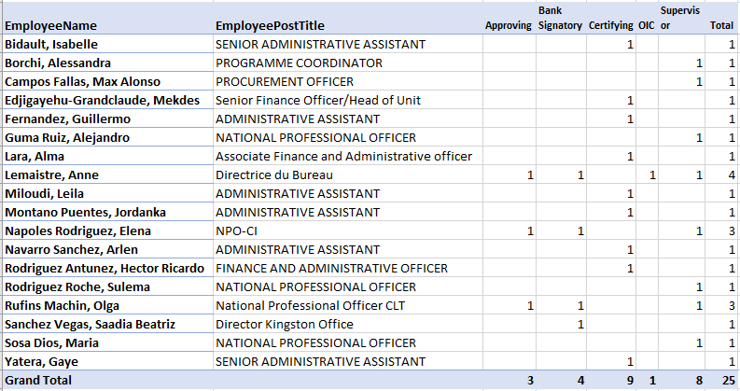

**Key policies and documented procedures relevant to the audited area**

Most of the processes of the office are supposed to be carried out in line with the Admin Manual and the HR Manual.

**IT support and key systems:** Most of the Office is on Windows 10.

|  |
| --- |
| DATA ANALYSIS |

Between 1 January 2019 to 14 June 2022, the Office initiated expenditures totalling US$5.9 million.

|  |  |  |
| --- | --- | --- |
| **Expenditure Type** | **Total** | **Percentage** |
| ZPOLIST (commitments made by the office) | 5 549 764 | 93 |
| TV (Staff travel) | 80 631 | 1 |
| FR (raised by the Office for activities from 2019 to 2021) | 305 723 | 5 |
| **Total** | 5 936 118 | 100 |

**Fund Reservations:** The Office uses fund reservations to pay the salaries of service contracts and insurance for consultants as well as travel for participants to workshops.

**Contracts:** The Office drew 2,464 contracts for a total amount of US$5,5m between January 2019 and June 2022 with a majority of contract for goods and services under the Transcultura project for the renovation of the Santa Clara Convent and materials and equipment of the renovated training centers.

|  |  |  |
| --- | --- | --- |
| **Order Type** | **Sum (USD)** | **Count** |
| GDSE – Goods and Services | 2 820 829 | 1 464 |
| CS - Contract for Services | 783 197 | 242 |
| 354 – Individual consultants | 752 235 | 358 |
| UTIL – Utilities | 551 317 | 94 |
| IMPT – Implementation Partnership Agreement | 285 588 | 5 |
| 205D – Video and Film Contracts | 157 990 | 22 |
| WORK – Small Work Contracts | 63 196 | 51 |
| OTH – Other | 53 752 | 49 |
| AM16 – Intergovernmental Body Allocation | 49 913 | 10 |
| PORD – Purchase Orders | 16 247 | 158 |
| 260 – Financing Activities Contracts | 13 609 | 8 |
| SSA – Special Services | 1 890 | 3 |
| **Total** | **5 549 765** | **2 464** |

**Top vendors:** Between 2019 and 2022, the top vendors relate to Transcultura project, mostly for the renovation of the Santa Clara Convent which will serve as a training centre. The third top vendor is ETECSA, the Telephone and internet provider for the Office and the project, which services are very costly due to the monopoly it has in the country.

|  |  |  |
| --- | --- | --- |
| Vendor Name | Total | Activity |
| SIERO LAM S A | 518 378 | Restoration of the Santa Clara Convent as a training centre - Wood for Structures |
| PINTURAS MONTO S.A.U. | 481 042 | Restoration of the Santa Clara Convent as a training centre - Paint and waterproof |
| ETECSA Grandes Clientes | 357 540 | Telephone and Internet service provider |
| UNIVERSITY OF THE WEST INDIES | 285 588 | Virtual and blended capacity building for 180 professors and 150 beneficiaries |
| DICAPA LOGISTIC SA | 274 812 | Material and IT equipment provider |
| DANOFFICE IT | 202 315 | IT equipment |
| ULMA CYE S. COOP Total | 187 913 | Scaffolding parts and accessories for the renovation of the Santa Clara Convent |
| GRUPO PLASVISA EXPORT S L | 183 573 | Materials for the renovation of the Santa Clara Convent |
| BIONDOLINO Nathan Michael | 140 512 | Consultant for monitoring and reporting of the Transcultura project |
| SANCHEZ CALVO CARIBE, S.L. | 123 735 | Hydro sanitary materials for the restoration activities of the Convent of Santa Clara |
| IRVINE PANAMA S.A | 115 690 | Two vehicles and air conditioning |
| Fondation Haiti Jazz | 111 600 | Audiovisual concerts |
| CONEXXIA BROADCAST SERVICES SL | 108 307 | Computers for Audio Systems |
| EMERGING MARKETS COMMUNICATIONS | 102 497 | Internet connexion service via satellite |
| ETECSA-Móvil La Habana-Ingresos | 91 417 | Mobile telephone and land line services |
| LINPORT S A | 90 424 | Sanitary Furniture and Faucet & accessories for the Santa Clara Convent |
| CAMPOS FALLAS Max Alonso | 90 121 | Procurement Officer |
| PERFECCIONAMIENTOS TECNICOS | 69 470 | Personal Protection Equipment and accessories for the Santa Clara Convent |
| Crimson Interactive Inc | 65 340 | Interpretation Services (capacity building Youth) |
| UNION ELECTRICA | 63 433 | Power supply service |
| ADAPT FOR ARTS CIC | 60 975 | Platform and virtual courses in English and Spanish on Grant Proposal Writing in the Culture and Creative Industries sector for young artists and cultural professionals |
| FUNDACION DEL NUEVO CINE | 60 000 | 10-online courses on film production targeting 120 young experts and professionals in the cultural and creative industries in the Caribbean, to be selected by UNESCO |
| NEIGE ET SOLEIL VOYAGES SA | 58 593 | Air Tickets for participants to musical meeting WOMEX, along with selected bands |
| AVILA DOSAL Raquel | 56 630 | Consultant for communication of the Transcultura project |
| RAGGIO COMUNICACION SL | 51 981 | Stationery products for the support to the office work and supplies (Tshirts, masks, bags, etc) for the Visibility and Communication related material the Programme. |
| FERRETERIA Y LIMPIEZA, S.L.U | 48 698 | Cleaning company |
| VADEL S.A.S. Total | 47 511 | Supply of mobile phones, soccer outfits for 514INT4000, materials and equipment for the Workshop School in Santa Clara Convent |
| HASENKAMP RELOCATION SERVICES | 46 831 | Relocation services for Project Appointments on the Transcultura project |
| GRUPO URANO, S.A | 43 866 | Goods + 1 Printer + accessories + start – up services |
| KERASOL 2000 S.L | 43 469 | Copper Channels and accessories for the Santa Clara Convent |
| Financiera Cimex S.A. | 40 468 | Fuel for official vehicles and generator |

**Fund Reservations Profile**

The Office uses fund reservations to pay the salaries of service contracts and insurance for consultants as well as travel for participants to workshops.

|  |  |  |  |  |
| --- | --- | --- | --- | --- |
| **By Certifying Officer** | **2019** | **2020** | **2021** | **Total** |
| **EXB** | **3 276** | **4 304** | **24 846** | **32 425** |
| G_FERNANDEZ | 3 276 | 4 201 | 24 503 | 31 979 |
| H_RODRIGUEZ- | | 103 | 343 | 446 |
| **RP** | **53 389** | **50 362** | **168 157** | **271 907** |
| A_LARA | 323 | 50 |  | 374 |
| G_FERNANDEZ | 53 065 | 49 808 | 59 043 | 161 916 |
| H_RODRIGUEZ- | | 504 | 109 114 | 109 617 |
| **CRP** | **334** | **1 023** | **34** | **1 391** |
| A_LARA |  | 1 023 |  | 1 023 |
| G_FERNANDEZ | 334 |  |  | 334 |
| H_RODRIGUEZ- | |  | 34 | 34 |
| **Total** | **56 998** | **55 688** | **193 037** | **305 723** |

**Travel Data**

The Office’s staff does not travel extensively mostly due to the COVID-19 pandemic. The table below shows the total duration on mission for the Office’s staff.

|  |  |  |  |  |  |
| --- | --- | --- | --- | --- | --- |
| **Traveler Last Name** | **Traveler First Name** | **2020** | **2021** | **2022** | **Total** |
| **Lemaistre** | Anne (appoint 2022) | 45 | 11 | 13 | 69 |
| **Borchi** | Alessandra |  | 29 | 29 | 58 |
| **Guma Ruiz** | Alejandro |  | 46 |  | 46 |
| **Navarro Sanchez** | Arlen |  | 29 |  | 29 |
| **Rufins Machin** | Olga | 14 |  |  | 14 |
| **Cantillo Ponce De Leon** | Lisveth |  | 13 |  | 13 |
| **Rodriguez Antunez** | Hector Ricardo | 2 | 10 |  | 12 |
| **Napoles Rodriguez** | Elena |  |  | 11 | 11 |
| **Gonzalez Toirac** | Humberto | 5 |  |  | 5 |
| **Campos Fallas** | Max Alonso |  | 3 |  | 3 |
| **Varela Labarrere** | Sandra Adelaida | 2 |  |  | 2 |
| **Chen** | Haojun |  | 2 |  | 2 |
| **Tejeda** | Franklin Jesús |  | 1 |  | 1 |
| **Herrada Hidalgo** | Antonio |  | 1 |  | 1 |
| **Grand Total** |  | **68** | **145** | **53** | **266** |

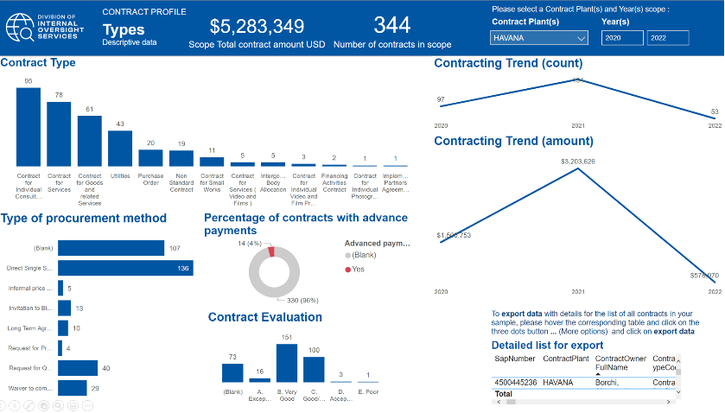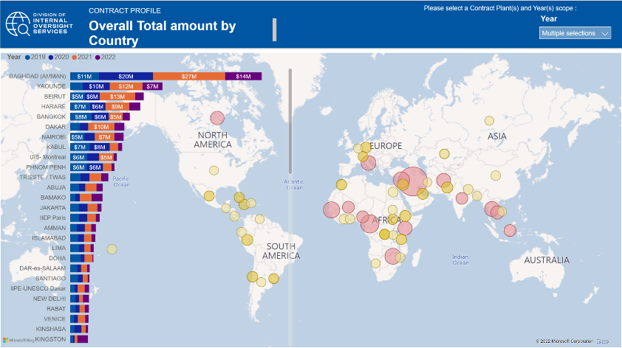**Contract Profile**

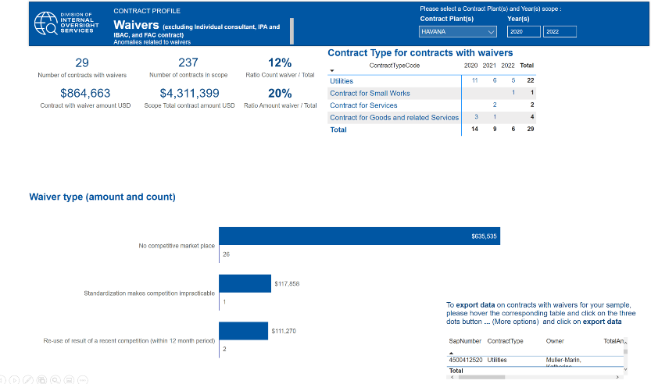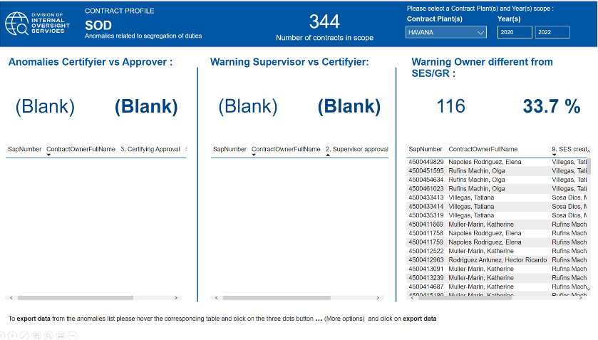

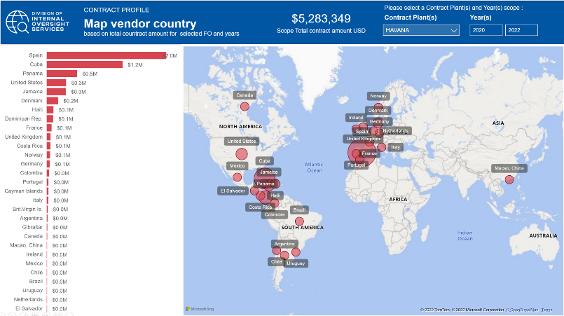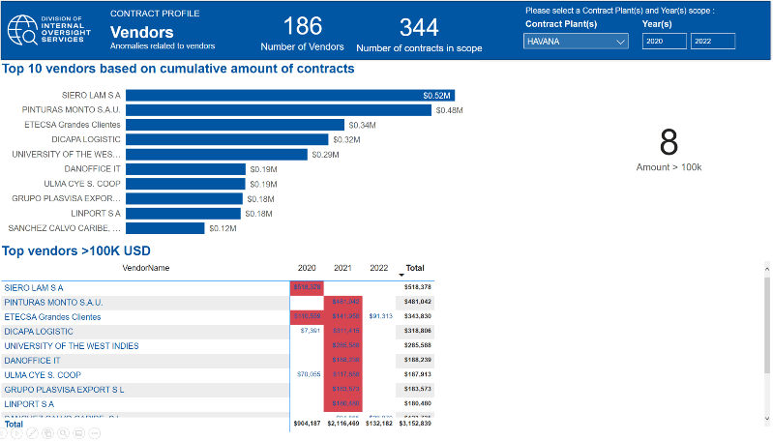

|  |
| --- |
| INFORMATION AND COMMUNICATION |

**Internal reports used and systems for data extraction:**

The Office uses the corporate tools iRIS.

**Social media reports for any positive or negative press about the programme/projects:**

The Office maintains a website in English and Spanish with links to UNESCO news as well as publications relevant to the country. It also has a link to the Portal of Culture of Latin America and the Caribbean covering the Organization´s activities and results in the LAC region. The Office also keeps active Facebook and Twitter accounts in Spanish.

|  |
| --- |
| PARTNERSHIPS |

**UNESCO Chairs**

* There are 17 UNESCO Chairs in the region including 12 in Cuba and 6 in Dominican Republic.

|  |  |  |  |  |  |  |  |
| --- | --- | --- | --- | --- | --- | --- | --- |
| **ID** | [**Chair Title**](javascript:) | [**Country**](javascript:) | **Name of host institution** | **Date** | [**Sector**](javascript:) | **FO/CAT1** | **Fields/Disciplines** |
| 76 | Chaire UNESCO de gestion universitaire | Cuba | Universidad de La Habana | 14/07/93 | ED | IESALC, Havana | Gestion de l'enseignement supérieur. |
| 474 | UNESCO Chair in Culture and Development | Cuba | Centro de Superación para la Cultura | 30/12/1899 |  |  |  |
| 1 252 | UNESCO Chair on Intercultural Dialogue | Cuba | Casa de las Américas | 01/11/17 | SHS |  | Intercultural dialogue. |
| 77 | Chaire UNESCO en sciences de l'Education | Cuba | Instituto Pedagógico Latinoamericano y Caribeño (IPLAC) | 06/01/94 | ED | IESALC, Havana | Sciences de l’Education ; Formation des enseignants. |
| 79 | Chaire UNESCO en sciences de la conservation des biens culturels | Cuba | Centro Nacional de Conservación, Restauración y Museologí­a (CENCREM) | 19/01/95 | CLT | Havana | Conservation et restauration des biens culturels. |
| 366 | UNESCO Chair in Culture and Development | Cuba | Centro Nacional de Superación para la Cultura | 25/01/02 | CLT | Havana | Culture and Development. |
| 364 | Chaire UNESCO de biomatériels | Cuba | Universidad de La Habana | 27/06/98 | SC | Havana | Química macromolecular; Cerámicas y composites; Síntesis química y sustancias naturales, calidad y computación. |
| 1 115 | UNESCO Chair on Agroecology and Sustainable Development | Cuba | The Agrarian University of Havana | 25/11/15 | SC | Havana | Agroecology and sustainable development. |
| 1 049 | UNESCO Chair on Agricultural Biotechnology for Local Development | Cuba | University of Granma | 27/03/14 | SC | Havana | Agricultural biotechnology and sustainable development. |
| 962 | UNESCO Chair in Environment and Development | Cuba | Higher Institute of Applied Science and Technology (InSTEC) | 22/02/12 | SC | Havana | Environment. |
| 78 | Chaire UNESCO en gestion de l'information dans les organisations | Cuba | Universidad de La Habana | 05/01/93 | ED; CI | Havana | Gestion de l'information dans les organisations. |
| 1 086 | UNESCO Chair "Felipe Poey y Aloy” on the Promotion of a Scientific Culture | Cuba | Universidad Central “Marta Abreu” de Las Villas | 27/03/14 | SC | Havana | Basic sciences. |
| 1 035 | UNESCO Chair on Social and Academic Inclusion for Disabled People with Special Educational Needs | DR | Universidad Iberoamericana | 29/11/13 | ED |  | Special needs education. |
| 383 | Chaire UNESCO pour la paix, les droits de l'homme et la démocratie | DR | Universidad Autónoma de Santo Domingo | 11/04/99 | SHS |  | Culture de la paix ; Droits de l'homme et démocratie. |
| 1 044 | UNESCO Chair on Water, Women and Governance | DR | Instituto Global de Altos Estudios en Ciencias Sociales (IGLOBAL) | 19/02/14 | SC | Montevideo | Water, women and governance. |
| 631 | UNESCO Chair in Communication, Democracy and Good Governance | DR | Pontificia Universidad Católica Madre y Maestra | 11/06/03 | CI |  | Communication and Culture of Peace. |
| 952 | Chaire UNESCO en sciences sociales, politiques publiques et gouvernance démocratique | DR | Instituto Global de Altos Estudios en Ciencias Sociales | 12/06/10 | SHS |  | Sciences sociales, des politiques publiques, de la gouvernance démocratique, des sciences politiques et des sciences juridiques. |
| 972 | UNESCO Chair on Teacher Training and Reading/Writing Research | DR | Pontificia Universidad Católica Madre y Maestra | 05/10/12 | ED | Havana | Teacher training and research into reading and writing. |

**UNESCO Category 2 Centres and Institutes**

There are four UNESCO Category II Centres in the area of culture in the Latin America and Caribbean region, including two centres working in the area of heritage site management, one in the safeguarding of intangible cultural heritage and one in book development and promotion.

Regional Centre for the Safeguarding of the Intangible Cultural Heritage of Latin America (CRESPIAL) (Peru)

The Regional Centre for the Safeguarding of Intangible Cultural Heritage of Latin America (CRESPIAL) was created in 2006 in an agreement between the Government of Peru and UNESCO with the objective to promote and support the safeguarding of intangible heritage in Latin America. More specifically, the Centre seeks to contribute to the formulation of public policies in the countries of the Region, based on the identification, assessment and dissemination of their living culture, and to carry out actions that will enrich the cultural diversity of Latin America, in accordance with the spirit of the 2003 Convention for the Safeguarding of the Intangible Cultural Heritage.

The UNESCO Regional Office for Culture, as delegated by the Director-General, participates in the Administrative Council of CRESPIAL.

Regional Centre for Book Development in Latin America and the Caribbean (CERLALC) (Colombia)

The Regional Centre for Book Development in Latin America and the Caribbean (CERLALC) works to create conditions for the development of reading societies by working to promote book production and circulation; reading and writing; book development capacity building; and the protection of intellectual property. Under the auspices of UNESCO, the Centre provides technical assistance for the formulation of public policies, knowledge generation, the dissemination of specialized information, and the development and promotion of training processes and spaces for consultation and cooperation within the region.

The UNESCO Regional Office for Culture participates in both the Council and Executive Committee of CERLALC and continues to support the Centre in the development of strategic plans and the identification of joint efforts and initiatives, including the provision of technical support the National Literacy Programme in the Dominican Republic. The Office further supports the period evaluation of the Centre in coordination with UNESCO Headquarters.

Regional World Heritage Institute in Zacatecas (Mexico)

The Regional World Heritage Institute in Zacatecas was created to support Member States of Central America and the Caribbean in the implementation of the 1972 World Heritage Convention, with an emphasis placed on the importance of regional studies and initiatives and to support mechanisms for regional cooperation and exchange of information and experiences.

The primary objectives of the Centre are to: strengthen capacity-building for the implementation of the World Heritage Convention in the region; contribute to international cooperation, especially within the region; contribute to sustainable development through the management of natural and cultural heritage; promote research on cultural and natural heritage, in particular for the properties inscribed on the World Heritage List; contribute to the creation and dissemination of information on regional World Heritage Sites; and share expertise with UNESCO, particularly the World Heritage Centre, and cooperate with Secretariats of other UNESCO cultural conventions related to heritage.

Regional Heritage Management Training Centre "Lucio Costa" (Brazil)

The Regional Heritage Management Training Centre “Lucio Costa” was created to support Spanish and Portuguese-speaking countries in South America, Africa and Asia in the implementation of the 1972 World Heritage Convention. More specifically, the supports the World Heritage Centre in the promotion of training and research activities to contribute to the implementation of the Convention, with its programmes and activities focusing on training and the sharing of best practices in heritage management. To this end, the Centre provides assistance to the region for the strengthening of national capacities in the field of heritage management and to promote the participation of relevant stakeholders in initiatives related to heritage. Moreover, in addition to strengthening capacities for heritage management in the region, the Centre acts as a reference centre for education, research and training and a platform for networking and skills in the field of heritage through projects, programmes and courses, serving as a knowledge base on conservation, preservation and management, among other topics.

|  |
| --- |
| PRELIMINARY FINDINGS |

The audit team met with the Office (HAV/DIR and AO), PAX, ADM/ADS and noted the following.

**PAX**

* Staff: Long vacancy for the Culture Programme Specialist.
* Field Reform: The government of Cuba is very keen in keeping the office.

**ADM/ADS**

* The Cuban government provides the office premises, and the Office covers the maintenance.
* Project: The $15m Transcultura project funded by the EU is difficult to implement because of the embargo and restrictive markets (difficulties to buy laptops and US products).
* Procurement: Most contracts go through the CC but there are issues with the procurement Officer on some big procurement. Casting issues with the procurement officer who is not helpful and does not do the contracts well. He could not do the risk matrix.
* CLT Staff: there were delays in getting the project officer due to conflicts between ADG/CLT and the Director of the office who wanted to manage the project directly while the Sector wanted a PS/CLT.
* The PA worked remotely since Cuba was closed early 2020.

**Office**

* The embargo impairs and delays the implementation of Transcultura.
* The Procurement Officer does not provide quality support to the Programme Officers and is not diligent in his work. His performance appears to be weak and represents a bottleneck to the procurement process. The certifying officers declined many of the contracts he drafted due to mistakes, and he does not conduct market surveys.
* Staff: there is no SC staff and the CLT/PS recently joined the Haiti Office as a Head of Office.

**Main issues**

The main preliminary findings identified relate to the following:

* The Office’s role in the Field Network reform.

As the office serves as the Regional Office for Culture in Latin America and the Caribbean, as the Cluster Office for Cuba, the Dominican Republic and Haiti and as UNESCO’s Representative Office for Cuba and the Dominican Republic, it has a broad mandate at the regional, subregional and national levels.

The Regional Office, as a result, works within regional, cluster/multi-country and national contexts. As Regional Office for Culture, the office is responsible for overall coordination of the implementation of the Culture Programme in the region. Within this role, the office is responsible for facilitating discussions and coordinating the distribution of Culture Regular Programming funding allocations for the biennium through a participatory process with colleagues in the region as well as coordinating with offices in the region to achieve the expected results within the Culture Programme.

At the cluster/multi-country level, the office is responsible for implementing programmes within all of UNESCO’s five areas of action in Cuba and the Dominican Republic in addition to providing representation of the Organization before national governments and counterparts as well as the United Nations System in these two Member States. While Haiti currently has a National Office in Port-au-Prince, the nation is also part of the cluster/multi-country capacity. Coordination has taken place in various ways.

These roles can be difficult to fulfil due to the operational challenges resulting from the embargo.

* The effects of the US embargo on the Office

The economic, commercial and financial embargo imposed by the US against Cuba for almost 60 years has been intensified since October 2019.[5] after the US Department of Commerce’s Bureau of Industry and Security (BIS) amended the Export Administration Regulations (EAR).

Procurement.

* + Limited number of suppliers: The US sanctions limit the number of suppliers willing to work with Cuba.
  + Freight costs. The Office cannot access the US market and is required to pay much higher freight costs for imports from third countries more distant from the island. In addition, when there are fewer options for suppliers, the purchasing process becomes more complex. Some of the companies with which UNESCO has long-term agreements to reduce costs and obtain better conditions are not allowed to make any offers to UNESCO in Cuba.
  + Re-export licenses. The Office encountered some difficulties in terms of re-export licenses for procured equipment, materials or technology subject to US embargo restrictions and to be provided to national partners as part of programmes. US-based companies supplying information and communications technologies with which UNESCO maintains global supply agreements are obliged to request special licences from the US Department of the Treasury to export their products to the Office. These permits are issued under the condition that said property is not transferred to any national entity, affecting the implementation of the Organization’s collaboration projects at the local level, increasing purchasing costs and eliminating the possibility of benefitting from post-sales services and better commercial warrantees.
  + Programmes and projects: Providing local counterparts and programme partners with procured goods is a central aspect of the successful implementation of the Office’s projects and programmes, specifically the Transcultura Programme, which relies significantly on the procurement of goods, equipment and materials for the restoration of the Santa Clara Convent and the Regional Cultural Training Hub. The Office consulted OPS/PRO to address concerns involving specific embargo regulations or legislation that could affect the administration or the programme as well as to exchange expertise and best practices.
  + Financial impact: The Office since 2022 can no longer pay vendors in Cuba in USD. The Office informed vendors that they would be paid in EUR and at worst would pay vendors through UNDP.
  + Travel / transportation: Sanctions against maritime companies shipping oil to the country, which has caused a significant reduction in supply and availability, affect the agriculture, public transport, food distribution and other aspects of economic and social importance in addition to making it more difficult for UNESCO to carry out cooperation actions in the country, such as capacity-building workshops due to the effect these limitations had on transporting participants from the different areas of the country for those events.

The Office goes through the Kingston Office for travel to save time. The Office would otherwise need to contact each airline individually to compare costs since the local travel agencies are restricted. Additionally, the Office’s staff travel cannot transit through the US resulting in higher costs and loss of time by way of flight paths through third-party countries.

* + Fraud risks: The audit will assess in the next interviews the potential for fraud. At this point, walkthroughs, discussions and documents reviewed indicate that controls are in place to respect segregation of duties over contracting and procurement, payment and creation of vendors proper procedures. The former director had introduced proper procedures through checklists and systematic filing and recording of administrative actions and meetings.
* Transcultura: Integrating Cuba, the Caribbean and the European Union through Culture and Creativity

The Transcultura project will likely be subject to the EU verification.

Signed in October 2019, the project is a four-year, 16.5 million USD European Union-funded regional programme. The Office is responsible for its implementation and is supported by Headquarters, the Liaison Office in Brussels, the Kingston cluster and the Port-au-Prince national Offices.

Prodoc. The project is structured around two complementary outcomes, both contributing to the overall objective of stronger cultural and socio-economic integration within the linguistically diverse Caribbean region and between the region and the EU: i) capacity building to strengthen professionalization in the cultural and creative sectors and ii) generating new opportunities for socioeconomic development and cultural cooperation. The project relies heavily on the establishment of a Regional Cultural Training Hub in Cuba and the restoration of the Santa Clara Convent, which will, once restored, serve as a key Hub institution.

Team: The project team consists of a P-4 project officer for the overall coordination, one P-3 procurement officer, a P-2 Monitoring and Evaluation officer and 3 NOB dedicated to different components (cultural training hub, twinning joint actions, scholarship and entrepreneurship) as well as programme and administrative assistants.

Partnerships**:** IPAs have been established with two regional entities: the Universityof the West Indies (UWI) and the CDB, specifically, their Cultural and Creative Industries Innovation Fund (CIIF). Both participated in conception and planning process as pre-selected partners by the EU. They play a central role in the delivery of regional capacity building as part of the Regional Cultural Training Hub, in the case of UWI, and in the design and implementation of incubator programme activities, in the case of the CDB.

Budget:

|  |  |  |
| --- | --- | --- |
|  | **All Years - Total** | **Year 1** |
| **Outcome 1** -** The professionalization of the cultural and creative sectors in the region strengthened | **9 522 765** | **3 517 807** |
| Output 1.1 - A regional Cultural Training Hub in Cuba, linked to relevant Caribbean institutions, established and capacities of culture professionals strengthened | 9 522 765 | 3 517 807 |
| **Outcome 2 -** Stakeholders and beneficiaries generate new opportunities for socio-economic development and cultural cooperation in the Caribbean and between the region and the European Union | **4 708 216** | **1 090 754** |
| Output 2.1 - Capacities for the development of new cultural projects, self-employment and start-up/scaling up activities strengthened | 1 578 983 | 506 049 |
| Output 2.2 - Joint actions and twinning for cultural exchange and cooperation in the Caribbean and between the Caribbean and the European Union promoted | 1 450 134 | 263 526 |
| Output 2.3 - Promotional mechanisms to support Caribbean Heritage Journeys within the different linguistic areas of the region and to generate opportunities for employment, income generation and regional integration created | 1 679 099 | 321 179 |
| **Communication and Visibility** | **332 510** | **75 024** |
| **Evaluation** | **200 000** | - |
| Subtotal - direct costs | 14 763 491 | 4 683 585 |
| Indirect Costs (7% on EU contribution) | 1 021 963 | 327 851 |
| **Contingency reserve\*\*\*** | **781 071** | - |
| **TOTAL** | **16 566 525** | **5 011 436** |

Expenditures: Expenditures as of July 2022 total $4m as shown below and have been initiated from different sectors and offices. The audit will focus on expenditures raised by the Havana office.

|  |  |  |
| --- | --- | --- |
| **PrchGrp** | **Description** | **Sum of Ordered Amount, (USD)** |
| 324 | Havana - CLT | 3 593 086,90 |
| 325 | Havana - CI | 13 104,00 |
| 329 | Havana - Adm | 149 708,83 |
| 374 | Kingston - CLT | 26 788,34 |
| 535 | Quito - CI | 5 000,00 |
| 564 | SJO - CLT | 5 800,00 |
| 694 | Brussels - CLT | 172 200,00 |
| PGB | CLT/EO | 70 500,00 |
| **Total** | | **4 036 188,07** |

The top vendors for the project are also top vendors for the Office and 15 large procurement actions in the list below have been sampled.

|  |  |  |
| --- | --- | --- |
| Vendor Name | Total | Activity |
| SIERO LAM S A | 518 378 | Restoration of the Santa Clara Convent as a training centre - Wood for Structures |
| PINTURAS MONTO S.A.U. | 481 042 | Restoration of the Santa Clara Convent as a training centre - Paint and waterproof |
| ETECSA Grandes Clientes | 357 540 | Telephone and Internet service provider |
| UNIVERSITY OF THE WEST INDIES | 285 588 | Virtual and blended capacity building for 180 professors and 150 beneficiaries |
| DICAPA LOGISTIC SA | 274 812 | Material and IT equipment provider |
| DANOFFICE IT | 202 315 | IT equipment |
| ULMA CYE S. COOP Total | 187 913 | Scaffolding parts and accessories for the renovation of the Santa Clara Convent |
| GRUPO PLASVISA EXPORT S L | 183 573 | Materials for the renovation of the Santa Clara Convent |
| BIONDOLINO Nathan Michael | 140 512 | Consultant for monitoring and reporting of the Transcultura project |
| SANCHEZ CALVO CARIBE, S.L. | 123 735 | Hydro sanitary materials for the restoration activities of the Convent of Santa Clara |
| IRVINE PANAMA S.A | 115 690 | Two vehicles and air conditioning |
| Fondation Haiti Jazz | 111 600 | Audiovisual concerts |
| CONEXXIA BROADCAST SERVICES SL | 108 307 | Computers for Audio Systems |
| EMERGING MARKETS COMMUNICATIONS | 102 497 | Internet connexion service via satellite |
| ETECSA-Móvil La Habana-Ingresos | 91 417 | Mobile telephone and land line services |
| LINPORT S A | 90 424 | Sanitary Furniture and Faucet & accessories for the Santa Clara Convent |
| CAMPOS FALLAS Max Alonso | 90 121 | Procurement Officer |
| PERFECCIONAMIENTOS TECNICOS | 69 470 | Personal Protection Equipment and accessories for the Santa Clara Convent |
| Crimson Interactive Inc | 65 340 | Interpretation Services (capacity building Youth) |
| UNION ELECTRICA | 63 433 | Power supply service |
| ADAPT FOR ARTS CIC | 60 975 | Platform and virtual courses in English and Spanish on Grant Proposal Writing in the Culture and Creative Industries sector for young artists and cultural professionals |
| FUNDACION DEL NUEVO CINE | 60 000 | 10-online courses on film production targeting 120 young experts and professionals in the cultural and creative industries in the Caribbean, to be selected by UNESCO |
| NEIGE ET SOLEIL VOYAGES SA | 58 593 | Air Tickets for participants to musical meeting WOMEX, along with selected bands |
| AVILA DOSAL Raquel | 56 630 | Consultant for communication of the Transcultura project |
| RAGGIO COMUNICACION SL | 51 981 | Stationery products for the support to the office work and supplies (Tshirts, masks, bags, etc) for the Visibility and Communication related material the Programme. |
| FERRETERIA Y LIMPIEZA, S.L.U | 48 698 | Cleaning company |
| VADEL S.A.S. Total | 47 511 | Supply of mobile phones, soccer outfits for 514INT4000, materials and equipment for the Workshop School in Santa Clara Convent |
| HASENKAMP RELOCATION SERVICES | 46 831 | Relocation services for Project Appointments on the Transcultura project |
| GRUPO URANO, S.A | 43 866 | Goods + 1 Printer + accessories + start – up services |
| KERASOL 2000 S.L | 43 469 | Copper Channels and accessories for the Santa Clara Convent |
| Financiera Cimex S.A. | 40 468 | Fuel for official vehicles and generator |

* Human Resources: vacancies and lack of posts

The CLT/PS was responsible for the implementation of the SC programme in the cluster countries on top of implementing the CLT regional programme for LAC.

The CLT/PS post has been vacant since June 2022.

The performance of the procurement officer is not satisfactory. The audit will include the recruitment and performance assessment of the procurement officer in its test sample

|  |
| --- |
| AUDIT RATIONALE, SCOPE AND OBJECTIVE |

**Audit rationale**

The Office was last audited by the External Auditor in February 2016.

**Audit objective**

The objective of the audit is to provide assurance on the effectiveness of internal controls, governance and risk management processes of the Havana Office. Furthermore, review the efficiency, effectiveness and economy of the Office’s operations (including programme management, financial controls, procurement, travel, human resources management, security, IT, and general administration).

**Audit scope and period**

The audit will cover the Programme activities from 1 January 2020 to June 2022, the audit team may also review other periods if necessary. The audit is planned as a full scope exercise. The audit will cover the following areas:

* Overall governance of the Office (including objective setting, planning, and risk management)
* Programme
* Financial control
* Contracting and procurement
* Travel
* Human resources
* General administration

**Audit methodology**

The audit will be performed in accordance with the *International Standards for the Professional Practice of Internal Auditing* and OS audit manual.

The audit will assess the functioning of internal controls within the defined scope in order to identify major risks to the achievement of the San Jose objectives. Action plans will be agreed to strengthen risk management and controls, and to improve operations where warranted.

The audit will be based on surveys, interviews, data analysis, documentation review, etc. The audit team will select the sampling techniques such as judgemental, statistical, representative, etc. to ensure the sampling approach remains relevant to the test objectives.

**Key milestones**

IOS will conduct the audit of the Office per these timelines:

| **Milestone** | **Planned date** |
| --- | --- |
| Notification letter | 16 June 2022 |
| End of planning | 25 July 2022 |
| End of fieldwork | 2 September 2022 |
| Draft report | 22 September 2022 |
| Final report | 15 October 2022 |

**Audit resources**

The budgeted days for this assignment are 110 days as follows:

|  |  |  |  |  |  |
| --- | --- | --- | --- | --- | --- |
| **Activity/ Persons-days** | **Planning** | **Fieldwork** | **Draft report** | **Finalization** | **Total** |
| Head of Audit (Soriano) | 1 | 0 | 1 | 1 | 3 |
| Principal Auditor (Grabiel) | 20 | 20 | 15 | 1 | 57 |
| Associate Auditor (Alvarez) | 20 | 25 | 4 | 3 | 51 |
| Total | 40 | 50 | 20 | 5 | 110 |

|  |
| --- |
| – Risk Matrix and Work Programme |

|  |  |  |  |  |
| --- | --- | --- | --- | --- |
| **Objective Title** | **Risk Description** | **Control Description** | **Concerns if any** | **Audit Test Steps** |
| GOV_O01_To carry out UNESCO's mandate effectively and efficiently in the field | Office's objectives may not be documented or up-to-date resulting in incoherent activities that do not align with UNESCO's mandate, national priorities or the UN framework | 1. Development of a UNESCO Country Strategy in consultation with government stakeholders.  2. Regular reviews to ensure alignment between UNESCO's and the countries' priorities and the Sustainable Development Goals (SDG) | Dual role of the Office as a cluster to Cuba, DR and Haiti as well as a Regional office for Culture in LAC. | Verify that:  1. the UCS is up-to date and UNESCO objectives are valid and in line with the C/5 and national priorities 2. government stakeholers, national commissions along with the UN System (UNSDCF Framework) have been consulted in setting priorities 3. if there are major divergences in priorities (based on stakholders interviews).    Through interviews with the PS, determine how the UCS was developed and their views on the regional needs. |
| GOV_O01_To carry out UNESCO's mandate effectively and efficiently in the field | Office capacity may be limited prevening (i) effective programme delivery and (ii) adequate support and advice to other offices for cluster and regional offices | 1. Establishment of a structure and dedicated posts based on the Office's role (regional/cluster/national) and volume.  2. The section for Administration Support (ADM/ADS) maintains the Administration unit structure based on the Office's role and portfolio and backstops in case of vacancy.  3. Programme sectors dedicate posts based on the role and needs of the Office.  4. The Office promptly fills vacant posts  NB: A field reform has been ongoing to optimize human resources in field offices | No SC/PS post allocated to the Office.  The recruitment of the ED/PS and CLT/PS is ongoing | **Review Workforce planning:** 1. Verify that staffing needs have been assessed by the FO, together with ADG of the Sectors, BFM & PAX and that a recruitment plan for all professional posts, NPOs and GS Staff has been prepared for the biennium.  2. Calculate and analyze staffing ratios and compare them with other offices (programme portfolio vs number of programme staff in unit, number of admin staff vs total staff number, cost of admin staff vs total costs of personnel in office).  3. Determine whether the office has enough staff to carry out its mandate and to what extent it depends on temporary staff vs. fixed term.  4. Verify the CLT Job Description has been revised to remove responsibilities over the SC programme and a new post is established for SC. |
| GOV_O01_To carry out UNESCO's mandate effectively and efficiently in the field | Insufficient donor funding may result in programme ineffectiveness and jeopardize the Office's sustainability | • The Office maintains and regularly updates a Resource Mobilization plan in accordance to the UNESCO Country Strategy and the C/5 • BSP monitors that FOs maintain and regularly update their Resource Mobilization plans  • BSP's 2021 guidance note field offices to develop a resource mobilization plan • BSP deployed regional experts in Resource Mobilization (Dakar, Bangkok, Jakarta and Nariobi, San Jose and Beijing) to cultivate donor relations | The Office has a 2018-2019 RM plan, since then, funds for Transcultura project and UBRAF for Haiti have mobilized. | 1. Interview the Office to assess whether it has benefited from the support of Resource Mobilization Officer located in the San Jose audit.   2. Benchmark the cost effectiveness of the office (Cost of maintaining the Office VS Money spent from VC) with other offices in the region. |
| GOV_O02_To commit to the UN Reform | Insufficient resources and staff time to participate in the UNCT meetings may prevent the Office from receiving funds raised through the UN planning and programming | • UNESCO's representatives or their alternate participate in the UNCT meetings   • BSP deployed regional experts in Resource Mobilization (Dakar, Bangkok, Jakarta and Nariobi, San Jose and Beijing) to cultivate donor relations and provide support in the UN planning and programming excercises. |  | **UN Reform** 1. Interview the Resident Coordinator and use the interview guide to:  - determine whether UNESCO's activities are consistent with national priorities and needs - UNESCO contributes to the UN Framework and works well with other agencies   2. Verify thatthe Office is represented at all UN Country Team meetings.  3. Through interviews of Office's personnel, assess the Office's capacity to participate in the UN inter-agency mechanisms meetings and working groups as well as the effectiveness of these meetings. |
| GOV_O03_To fulfill its UNESCO focal point role | Lack of engagement with partners can result in missed opportunities as well as weak monitoring and misuse of UNESCO's logo | Sectors have assigned field offices focal point role for engaging with patners including Category 2 Centres and Institutes, UNITWIN/UNESCO Chairs, etc   These roles and responsibilities have been communicated, documented and updated as needed. | There are 12 UNESCO Chairs in Cuba and 6 in DR | **UNESCO Network** Verify that:  1. the Office is aware of the UNESCO's network in the region and engages with them on a regular basis.  2. Any inactive partner has been reported to the Sectors for records' update. |
| PRO_ O01_To implement activities/ projects in accordance with the project plan | Delays in Project implementation will negatively impact our relationship with donors and UNESCO's reputation | Projects documents contain the mandatory information for better planning and execution | Cuba is under the embargo resulting in a daily challenge in terms of implementation. It is difficult to import materials, get visas for nationals, etc. It took one year to get the equipment for the Santa Clara renovation. Constant anticipation and negotiation with the governments is needed. | **PROJECT MANAGEMENT** Select a judgemental sample of RP activities and Projects. Review the project documents and verify that: **Planning** 1. the project document is complete and includes (i) relevance, (ii) focus, (iii) a clear logical framework with realistic performance indicators at the output level, (iv) risk analysis; (v) budget by activity, (vi) timeline, (vii) monitoring and evaluation framework; (viii) sustainability; 2. the project risk analysis is done correctly and identify all high risks and mitigating measures; 3. the budget allocates adequate staff time for cost recovery (HoO and Programme Specialist); 3. the monitoring mechanisms are adequate to track progress and mitigate risks identified, and if applicable the project steering committee is established; 4. if applicable the project has been screened by the High Risk Project Committee prior to agreement signature.  **Monitoring and Evaluation**  5. activities are on schedule and if not, delays have been communicated with the donor 6. a monitoring and evaluation framework is in place and updated on a regular basis to track progress by outputs, activities and expenditures;  7. a mid-term and final evaluations have been conducted as required; 8. any lessons learnt has been documented and shared (via SISTER or other means)  **Reporting** 9. financial and narrative reports are submitted in line with donor requirements 10. the donor is satisfied with the communication surrounding the project (interview of the donor)  11. implementation progress is recorded in SISTER  12. Reports on gender markers are correctly done when applicable (in SISTER) |
| PRO_ O02_To embed Global priority Gender in projects | PM_Global priority Gender is not embedded in the operations and programmes of the Field OfficeUNESCO Priority Gender Equality Action Plan 2014-2021 is not being implemented | Programmes/projects focus on the global priority Gender Equality  The Office has assigned a staff the Gender Focal Point role |  | **Gender Markers** For a selected sample, verify that:  1. the project contain clear assumptions, baselines and RBM linkages to implement and monitor progress on Gender Priority 2. gender markers have been correctly assigned and corresponding reporting indicates the effort required, results achieved and captures monitoring information  Through interviews, verify if:  1. a staff has been assigned the role of Gender Focal Points 2. trained on Gender Equality training and  3. is being consulted for workplace issues or developing project proposals/design and reviewing the office workplans |
| PRO_O03_To produce publications efficiently according to UNESCO’s publication guidelines | Lack of quality control over publications expose UNESCO to reputational risks | Annual publication plan and publications produced. |  | 1. Verify that the office prepares an annual publication plan which is submitted to DPI.  2. Assess that the publication planning addresses (i) objectives, (ii) relevance, (iii) target audiences, (iv) linguistic diversity, (v) timeline, (vi) cost efficiency, (vii) distribution plan and strategies and impact measurement and (viii) qualitative and quantitative indicators to measure the distribution and impact of a publication.  3. Review a sample of publications produced by the Field Office. |
| PROC_O01_To contract the most appropriate service, technical expertise | Poor planning leads to sub-optimal procurement outcomes.   • R01. Contract price may be too high resulting in financial losss   • R02. Goods and services may not be verified and inspected resulting in financial loss  **•** R03. Performance assessment is not objective resulting in resorting to poor-performing vendors | C01. The contract is awarded based on competitive selection and if not, evidence of review for cost reasonableness is documented.  C02. The contract unit triggers instalment payments based on receipt of the deliverables in CMT.  C03. Performance assessment is recorded in CMT before final payment.  • Certification and Approval in system to ensure compliance with AM: - Clear TOR including SMART deliverables - Competitive selection, comparison for commitment above certain amounts - Verification and inspection of deliverables for contracts and M&E for IPAs (SES) - Contracts Committee compliance review for commitments above $150 000  • Segregation of duties: Certifying and Approving Officer | There is an international procurement officer but feedback on his support to the programme is negative. | **Contracting and Procurement** For sample of purchase orders created in SAP, verify that:  1. the purpose of procurements is justified and relevant to the project’s/activity’s objectives and foreseen in the project documents if VC funds are used  2. the terms of reference (or product specifications) are well defined, framed before initiating procurement action, clear and complete to allow for price comparison. (NB: Requirements must be stated clearly, concisely and logically in functional and performance terms, unless specific technical requirements are needed. Equal opportunity must be provided for all potential suppliers to offer goods and the usage of a brand name shall be avoided. *Sustainable procurement criteria should be considered to the extent possible)*   3. the contract is awarded in a competitive manner and if evidence of review that the cost is reasonable is documented (through waivers, IPA, LTA, etc);  4. the contract is managed correctly, i.e. a) SES are done after receipt and inpsection/verification of the deliverables (PAs, narrative reports are submitted on a regular basis,  5. performance assessment is done in an objective manner. |
| FIN_O01_The office effectively manages the budget and monitors its financial performance | Inadequate budget management practices lead to poor budget implementation, budget cross-charging and ULOs | • The Certifying Officer is responsible for verifying that the correct budget code is used and supporting document is provided when certifying a payment.    • The budget holder can verify payments from a budget code and verify achievement of expected results with funds "decentralized" or "authorized"  • SOD is in place for posting and releasing payment  • BFM reminds Administrative units of pending unliquidated obligations for follow-up and clearance |  | **Budget Management** 1. Perform a walthrough with the AO unit to identify the Office's controls that ensure payment is charged to the right budget codes including those of decentralized funds including GLO, RAS, RAF, etc .   2. Select a judgmental sample of transactions to verify that: they are charged to the correct budget code.    3. Determine how the Office monitors budgets (e.g. budget implementation rates, obligations, advance payments etc.) and obtain supporting documentation for review to assess the control, its regularity and involvment of Head of Office and senio staff.  3. Analyze the budget implementation rates and the level of unliquidated obligations for the different Units and activities of the Office (including for the Office Running Costs).   4. Review the actions taken by the office to address exceptions. |
| FIN_O02_To process payment correctly | Input errors in vendor creation and payment process can result in funds misappropriation, unfunded liabilities, compromised financial reporting and financial loss | • SOD is in place for posting and releasing payment • SOD is in place for creating vendor bank account    • Adequate supporting documentation provided for bank account creation (bank document and official ID)  • The Certifying Officer is responsible for verifying that the correct budget code is used when certifying a payment.   • The budget holder can verify payments from a budget code | The Office uses the Metropolitano bank and uses bank letters to transfer funds to individuals and issues checks to companies. | **Controls over vendor creation and payments** 1. Confirm independently with the local bank(s) that all open and recently closed Office bank accounts were opened by the CFO or Treasurer and the Office does not hold any other bank accounts.   2. Verify that the Head of Office when appointed signed and returned acknowledgement of financial management and control (delegation of authority) to the CFO.   3. If the Office still uses bank transfer letters, establish the workflow to determine whether proper segregation of duties is in place and test a sample of payments. If the Office uses the online bank platform, perform a walkthrough of the payment process on the bank website to determine whether proper controls are in place (dual validation over payments) and obtain the list of all the vendors created online during the walkthrough to avoid any file alteration.   4. Perform a walkthrouhg of payment process in SAP and verify that segregation of duties is respected between the posting of invoices (FB60), clearing of payment (F-53) and performance of the bank reconciliation.    5. Perform a walkthrough of the bank vendor creation process and verify that vendors are first created in MOUV first and that bank account details match those in the internet banking tool. In the absence of a banking tool, select a sample of payments and verify that bank account details in bank transfer letters match those in SAP and are supported by official bank documents that prove vendor name match the bank account information.   6. Select a judgemental sample of payments to assess the effectiveness of the above controls and verify that the payment is (i) valid, (ii) authorized and (iii) supported. |
| FIN_O03_To monitor advance payments | Weak monitoring over advance payments or outstanding obligations may result in financial loss | • BFM reminds Administrative units of pending unliquidated obligations for follow-up and clearance  • Bank reconciliations are performed on a regular basis |  | **Advance Payments**  1. Verify if the Administrative Unit monitors advance payments (salary advances, travel advances, advances to staff to incur programme expenditure, advances to contractors and suppliers etc.) and liquidates or recovers in a timely manner.   2. Verify that the Administrative Unit follows-up and clears outstanding unliquidated fund obligations (ULOs) on time. Review a sample of outstanding ULOs and verify they are legally valid (include ULOs created in different FABS modules, all large value and long outstanding ULOs, ULOs which typically should have expired, e.g. for contracts and missions which have been completed etc.).  3. Completeness on refund of TVA (where applicable)  4. Verify through data analytics SOD is respected for the commitment (DUO CMT reports, etc) |
| FIN_O04_To use the petty cash for the intended purpose | • Petty cash may not be kept in a locked and safe area  • Transactions are no recorded correcly   and may result in theft and financial loss | Field Offices maintain petty cash in a safe and locked area, record petty cash transactions in SAP and perform regular reconciliations |  | **Petty Cash** Perform a surprise count of the petty cash kept in the Office and verify that:  (i) cash is kept in a locked area (ii) cash transactions are recorded in the SAP petty cash account (iii) supporting documentation is maintained for cash receipt and disbursement (sample) (iv) segregation of duties is established for the cash management |
| HR_O01_To manage HoO and field staff performance | • Unclear performance objectives and deliverables prevent adequate assessment of staff performance  • Multiple input (HQ sectors and FO) into performance impairs the objectivity and effectiveness of the performance assessment | • HoO and all staff are subject to biennial performance review (Nidza Monthy maintains data)  • HRM follows-up on performance assessment to ensure completion |  | **Staff Performance management** 1. Establish if the annual performance agreement for the Head of the Office and staff have been prepared according to guidelines and approved by HQ.  2. For HoO, verify the adequacy and how specific the plan is with regard to results to be achieved. Resources to be mobilized or actions to be taken for this purpose  3. Confirm with HRM that all staff and HoO have performance objectives and evaluations in MyTalent  4. Select a sample of Job Descriptions and verify they are up-to-date  5. Assess whether SC are evaluated prior to contract extension. |
| HR_O02_To recruit staff effectively | • Flawed recruitment processes may lead to appointment of incompetent staff thereby impairing programmme delivery.  • Long post vacancies result in discontinuity in programme delivery | Compliance with policies and procedures for the selection and recruitment process  • Vacancy notices are published  • Balanced composition of panel reviewers  • Assessment records are documented | Select the Procurement Officer in the sample. | **Recruitment**  Select a sample of recruitment actions of Fixed Term (professional, NPOs, PAs) and temporary staff (SC) and assess their compliance with the recruitment policies. Verify that: 1. Job descriptions have been prepared and vacancy notes reflect the requirements of the job description and that it has been advertised externally for two weeks to one month for GS and for one month for NPOs and professional posts. PAs are at the discretion of the manager.   2. An evaluation panel's composition is compliant with the rules and candidates have been pre-selected against the essential requirements of the post and valid justifications for the final selected candidates have been documented.   3. Checks of candidates' references and credentials are documented for the recruited staff.   4. Determine if any posts have been vacant for more than 6 months and follow-up on the reasons for vacancy. |
| HR_O03_To manage individual consultants correctly | The lack of solicitation or fair competition for proposals can lead to excessively high consultant fees | Compliance with HRM 13.10  • Submission of at least 3 proposals for the foreseen assignment for contracts over $20,000 annually  • 3 CVs of qualified candidates  • Management of performance against deliverables |  | **Individual Consultants** Select a judgemental sample of Individual Consultants contracts, and verify that:  1. a comparison of 3 CVs was done for contracts below $20,000 and same process applies for repetitive contracts and for contracts above $20,000, the Office obtained proposals from at least 3 suitably qualified candidates  2. the experience in the CV is relevant and adequate and salary is aligned with consultants salary scales per range of years of experience.   3. TOR are appropriate and time-bound to provide adequate, clear and complete information on tasks which should be competitive in nature and not tasks that should only be performed by fixed term staff.   4. travel lumps for consultants are supported by clear cost estimates and travel plans.   5. evidence of deliverables and TOR fulfilment before payment is processed.  6. Performance assessment is recorded in CMT-DUO or on file. |
| HR_O04_To manage staff benefits effectively | Errors in the attribution of staff entitlements may negatively impact staff motivation and may lead legal risks | • Local and professional staff are given entitlements in line with the guidelines in the HR Manual as well as UN ICSC  • Second level review of entitlement and benefits by HRM |  | **Benefits and Entitlements** 1. Confirm that internationally recruited professional staff  are rotated out of the duty station once 2 year assignment has been completed for hardship duty stations and 5 years for non-hardship duty stations. 2. Verify that staff receive the relevant danger pay (US $ 1,600 per month) 3. For hardship duty stations confirm that P staff take Rest & Recoperation every 6 weeks to the designated destinations. 4. Salary calculation/benefits according to level of function and prevailing local salary rates 5. Assess that justification for salary of locally recruited staff is available, including justification for all increases.   6. Verify through a judgemental sample that payments of benefits and entitlements are supported. |
| HR_O05_To manage staff's presence effectively | Failure to monitor staff absenteeism can resulting operational inefficiency and financial losses. | • Fixed term staff and persons employed under temporary assistance record their annual leave, sick leave, etc on DUO TULIP  • The Office monitors leave for Temporary assistance staff (SCs, PAs and individual consultants) |  | **Sick, Annual, Mission Leave** Verify that the Office monitors annual leave, sick leave etc. for fixed term staff and persons employed under temporary assistance (SCs, PAs and individual consultants). |
| HR_O04_To manage staff's motivation and morale | Weak leadership or people's management may result in low staff morale, unethical staff behavior, low productivity, misconducts and fraud. | • HRM conducts a global staff survey annually to probe staff's morale and open channels for dialogue and feedback from staff  • Regular staff meetings, retreats and surveys to encourage staff to open up and provide feedback on management aspects that need improvement for a better working environment. |  | **Staff Survey** 1. Review the HR staff survey results (IRA)  2. Carry out a survey to take the pulse of staff morale, office ethics practices and determine staff fraud awareness i.e. whether they know how to identify and report fraud. |
| TRAV_O01_To support the programme implementation through the successful completion of essential missions | Travel unplanned resulting in excessive costs and poor project support. Staff forego/receive incorrect entitlements exposing the organization to litigation at ILO or unfunded liabilities. |  |  | **Travel**  1. Review the use of travel plan in terms of planning and organizing travel in the region.  2. Select a judgemtal sample of missions and verify compliance with applicable rules (including: identification of travel needs (travel orders), preparation of travel arrangements (travel plans, UNDSS security clearances, BSAFE certificates), payment processing (travel claims), mission effectiveness (mission reports))  3. Trace missions to tulip calendars to ensure staff record missions for proper monitoring of absenteeism or absence from the office/duty station. |
| GADM_O01_To provide staff with a safe, secure and healthy office environment | Noncompliance with Security Risk Management Measures (SRM Measures) and weak implementation of UNDSS recommendations, exposing staff to risks that could harm their wellbeing. | SRM Measures compliant premises |  | **Security and safety office environment** Verify that:  1. There a designated security focal point 2. The office possess a checklist for Security Risk Management Measures (SRM Measures) and is it in compliance with them 3. The UNDSS Facility Safety and Security Survey (FSSS) assessment was conducted and recommendations were implemented  4. Establish whether the Office participates in the SMT meetings |
| GADM_O02_To manage Office assets correctly | Inadequate controls over office inventory may lead to loss, theft, or damage | The Office itemizes, verifies and reports annually the office assets (non-expendable inventory) |  | **Asset Inventory**  Verify that: 1. an inventory of non-expendable items exist and items have a clear ID number.  2. items can be traced back to the inventory list (walkthrough or sample test).  3. controls are in place to prevent inventory items from being deleted without proper authorization.  4. an annual independent physical verification is conducted and discrepancies are followed-up and documented.  5. high value items on the inventory list exist (by video call for remote audits)  6. the inventory list is sent to BFM each year. 7. the disposal of items follows UNESCO policy and was properly authorized. |
| GADM_O02_To manage Office assets correctly | Weak controls over the vehicles may result in inappropriate and unsafe usage | • Log books are maintained daily and reviewed independently from the drivers   • Fuel consumption is supported and traced back to the car mileage |  | **Fixed Assets** (vehicles)  Verify that: 1. the number of vehicles is adequate for the staff size, operational needs and actual usages of the existing vehicles.  2. monitoring controls are in place, i.e. there is a (i) regular control of the daily log books for details on odometer reading, name of passenger, purpose of the visit, destination, signature of the passenger etc., (ii) an analysis of fuel consumption as well as the vehicle maintenance expenditure 3. the mechanism for filling up fuel in the office vehicles is well controlled (pre-paid coupons, or from designated gas stations etc.) and if not, discuss with AO the feasibility of improving the mechanism to prevent any possible misuse.    4. the insurance policies of the office vehicles is up-to-date and covers the entire period. |
| GADM_O03_To maintain Office premises fit-for-purpose and related costs reasonable | • The Host Country agreement may not provide for a rent free provision of office premises or those provisions may not be fulfilled. • Inadequate financial support from the host country for maintenance of office premises.  • Uncontrolled office maintenance expenditures may lead to financial losses. • Inadequate office premises may expose staff to safety risks | • Regular review and negotiation of the Host Country Agreement  • A budget is allocated to each office for their Office running costs   • Periodic cost monitoring with reports to management for decision making where costs can be optimized. | The HCA foresees free facilities for the Office.  Internet fees are however very high ($55,000 monthly for UN) | **Premises** Verify that: 1. the host country agreement includes adequate arrangement for the provision of offices (incl. maintenance, running costs) and responsibilities have been fulfilled by the host country.   2. premises are adequate for the current/planned size of the Office incl. location, connection, safety and security.   3. Review the reasonableness of annual expenses for the office maintenance and utilities (water, electricity, security, etc.) and establish if the office has a mechanism in place to monitor the expenses. |
| GADM_O04_To manage ICT usage in line with corporate requirements | Weak practices over data security and safeguarding of IT assets may lead to unauthorized access, theft, destruction, or corruption of data. | Use of ICT (phones, IT) in compliance with with corporate requirements. |  | **IT**  1. Determine if the office has major IT system/software different from those controlled by KMI and in case there is discuss with KMI on the risks such a system could bring to the network; 2. Check how many staff have taken the UNESCO Cyber Security Fundamentals; 3. Determine whether there is a process for regularly updating software, 4. Check if all end-user computers are running on latest Operating System i.e. windows 10; 5. Review the network architecture, check if; a. The office is connected through the latest equipment deployed by KMI (Future Version 2), cross check with DBS. b. WiFi is linked to corporate network, if so, what are the controls against intrusion;  6. Carry out a virtual visit of the server room to assess the adequacy of the data centers physical controls. Among other things check for: a. Physical access controls; b. elevated floor to control floods; c. Fire suppression systems d. Cameras e. temperature and humidity controls, etc.  7. Assess procedures for replacement, maintenance and disposal of IT equipment.  8. Check compliance with policies and procedures in AM item 9.13 |
| GADM_O03_To manage operations in a sustainable manner | Inaccurate data may prevent environmental improvement and sustainable practices | Currently no guidelines and rules exist for field office to report on the inventory data. |  | **Environmental Sustainability** Determine whether the Office takes initiatives to reduce its carbon footprint.Select the most recent environmental inventory report year and verify that information reported for air travel, non-air travel, energy consumption, mobile sources, water consumption and waste production, is accurate, complete and supported. |

|  |
| --- |
| Engagement Terms of Reference*Title of the Audit* |

Terms of Reference to be shared with the audit client at the end of the audit planning phase.

****Background****

This audit was included in IOS 2022/2023 Audit Work Plan. In response to Executive Board request[6] to achieving complete coverage in a 5-year cycle, IOS/AUD has developed a field office network strategy for the period 2022-2026 to increases the frequency of audits of field offices.

****Audit scope and period****

The audit will cover the office activities from 1 January 2020 to June 2022, the audit team may also review other periods if necessary.

This audit will focus on the following main areas:

* Programme and project implementation
* Contracting and procurement
* Financial Management

****Objectives****

The audit objective is to provide assurance to the Director-General on the effective functioning of the Office’s internal controls, as well as the efficiency, effectiveness, and economy of the Office’s operations.

The audit will assess the adequacy of the internal controls to achieve the office objectives. IOS/AUD will discuss with the audit clients Agreed Management Actions (AMA) to strengthen risk management and controls, and to improve operations where warranted.

****Audit methodology****

The audit will be performed in accordance with the *International Standards for the Professional Practice of Internal Auditing* and IOS audit manual.

The audit will be based on surveys, interviews with internal and external stakeholders, walkthroughs of processes, data analysis and documentation review. The audit team will select the sampling techniques such as judgemental (risk-based), statistical, representative sample to ensure the approach remains relevant to the test objectives.

****Stakeholder engagement form****

IOS will conduct the audit as per the workflow and timelines below. Without any objection from your end, IOS considers that you agree to adhere to these timelines.

Respecting agreed timelines allows IOS to deliver the audit plan on time and to better serve the Organization. As delays impact the implementation of other assignments, IOS would appreciate to be informed as soon as possible of any challenges that would affect the agreed timeline.

|  |  |
| --- | --- |
| Milestone | Planned date |
| Notification letter | 16 June 2022 |
| TORs shared with audit client | 16 June 2022 |
| Entrance Meeting | 24 June 2022 |
| Initial Risk Assessment / Start of Fieldwork | 25 July 2022 |
| Field mission | 22 August – 2 September 2022 |
| Exit Meeting / End of Fieldwork | 2 September 2022 |
| Draft report | 23 September 2022 |
| Client comments and AMAs | 7 October 2022 |
| Final report | 15 October 2022 |
| Client Satisfaction survey | 31 October 2022 |
| Release of AMAs in TM+ | 15 December 2022 |

****Audit resources****

The audit will be carried out by Ms Tuyet-Mai Grabiel, Principal Auditor and Ms Alicia Alvarez Gracia, associate auditor.

1. <https://en.unesco.org/fieldoffice/havana/about-office>
2. <https://worldpopulationreview.com/>
3. https://hdr.undp.org/en/content/download-data
4. The net ODA per capita consists of disbursements of loans made on concessional terms (net of repayments of principal) and grants by official agencies of the members of the Development Assistance Committee (DAC), by multilateral institutions, and by non-DAC countries to promote economic development and welfare in countries and territories in the DAC list of ODA recipients; and is calculated by dividing net ODA received by the midyear population estimate. It includes loans with a grant element of at least 25 percent (calculated at a rate of discount of 10 percent).
5. The US Department of Commerce’s Bureau of Industry and Security (BIS) amended the Export Administration Regulations (EAR) as part of the intensification of the US embargo against Cuba and Venezuela.
6. 211 EX/44 decision